Stray Cats in Beijing
北京流浪猫的现实问题
by Charlotte Landwehr

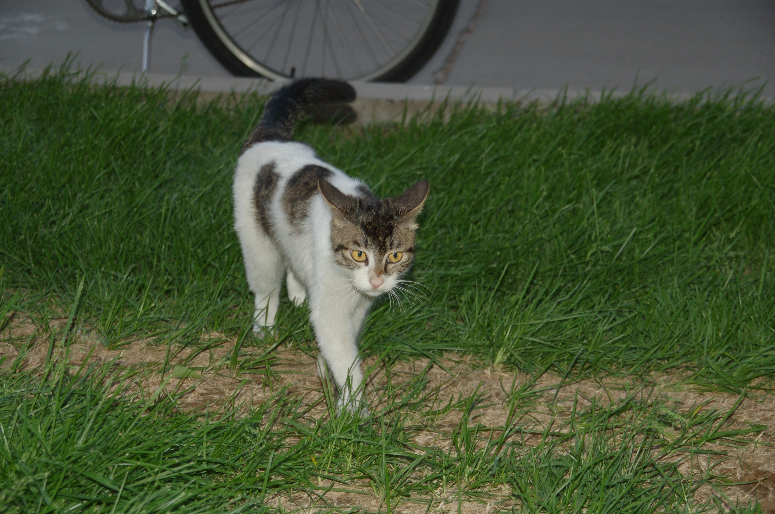
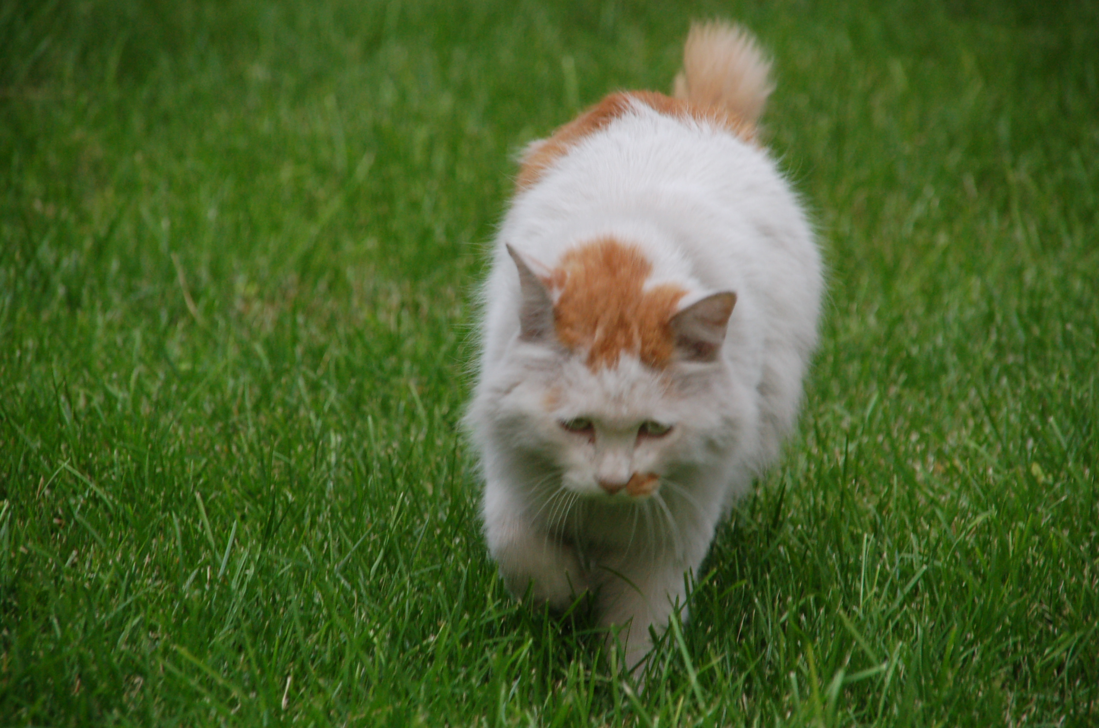
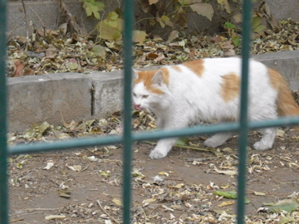
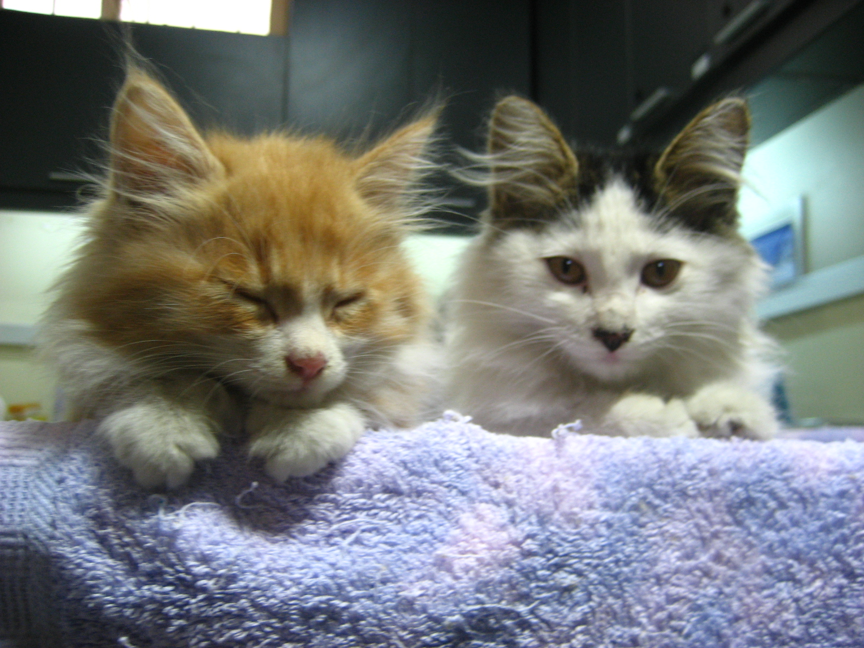

Acknowledgements

I would like to thank Michelle Bruce and Mary Peng for their encouragement and for the time they spent helping me gather information about stray cats in Beijing and in the revision of the project. They are an inspiration to me and I am very grateful, to be able to work with them.

Table of Contents

Acknowledgements. 2
Table of Contents 3
The Actual Problems of Stray Cats 3
Why are There so Many Stray Cats in Beijing? 5
What is the Best Way to Help Cats? 7
TRAP NEUTER AND RETURN 9
Humane Ways to Trap Cats 11
ADDRESSES FOR DONATIONS 15
Bibliography 16

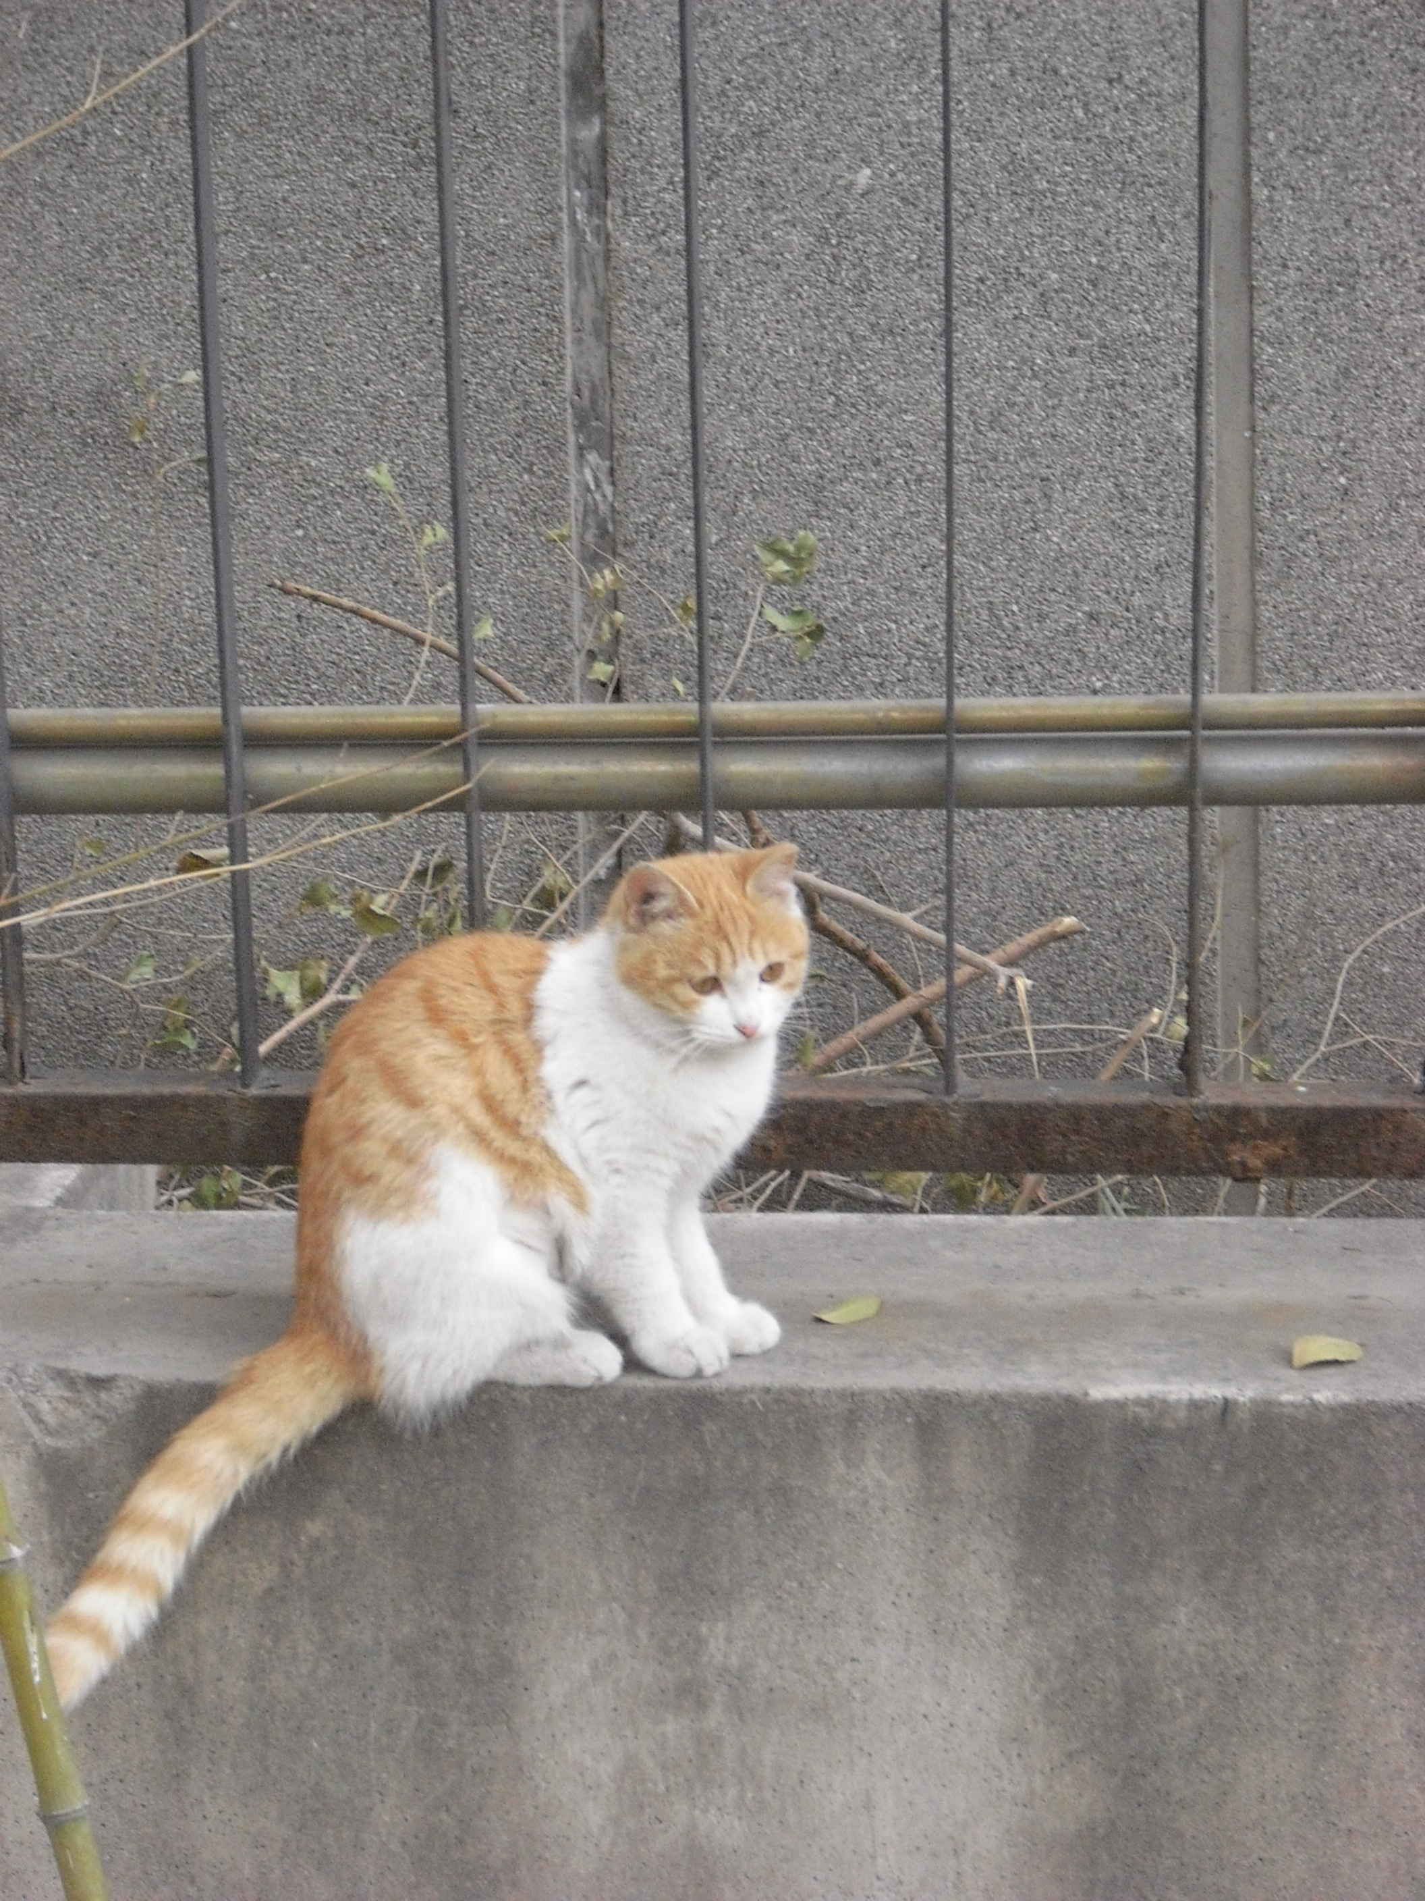

The Actual Problems of Stray Cats

流浪猫的现实问题

- 大约有上百万只流浪猫在街头徘徊，无家可归。（有人统计为50万，但是实际数字也
许更多）
- 面对如此众多的流浪猫，人们不胜其烦，因为它们穿行于垃圾堆，影响城市环境。
- 未做节育手术的公猫为争夺领地而不断打架，它们和母猫一起在夜间发出嘈杂的叫
- 如果流浪猫的数量上升，更多的猫会加入争战。
- 如果流浪猫的数量过多，它们会更容易感染疾病。
- Overpopulation. There might be about a Million cats on the streets. (500,000 have been counted but the are known to be much higher)
- The problem with so many cats is that people get easily fed up with them, because they get into the trash, make a mess and are feared to pose health risks. Also, not neutered male cats fight a lot for territory and female and male cats can be very noisy and therefore are annoying at night.
- When there is overpopulation the population expands exponentially. This means: If we don’t do something about it the problem will get worse by an accelerating speed.
- When there is overpopulation stray cats stand a much higher risk of getting diseases, being injured in catfights for territory or being mistreated by humans.
Diseases frequently diagnosed in stray cats - 这些疾病包括：

- 猫白血病
- 猫艾滋病（但是不会传染致人）
- 狂犬病
- 猫鼻气管炎、萼状病毒和猫肠炎, 除此之外，各种皮肤病，虫子，寄生虫也是常见的

- Feline Leukemia Virus
- Feline Immunodeficiency Virus, which is like Cat HIV (but is not
transmittable to humans, only to other cats)
- Rabies
- FVRCP: Feline Viral Rhinotracheitis, Calicivirus, and Panleukopenia. In
addition skin diseases, worms and parasites are very common.

The Dangers that Stray Cats Face

流浪猫面临的危险

- 很多猫被诱拐和杀害，人们剥其皮，食其肉。
- 猫皮被贴上别的动物皮毛的标签，然后出售到全世界。
- 每年全世界大学有一至两百万只猫被取皮，而其中大多数都来自中国。
- 误食鼠药
- 以垃圾为餐
- 被汽车撞
- 暴露于极端恶劣气候之中
- 在与其他猫争抢领地而争战时受伤
- 传染病
- 恶意的人
- 缺乏医疗救助
- 缺乏爱
- 在国际赛事来临，北京需要整顿环境的时期备受煎熬。（2008北京奥运
会期间）
- 被误解
- Many cats are kidnapped and killed for their fur and their meat.
- Cat fur is mislabeled and sold all around the world.
- There are approximately 1-2 Million cats worldwide each year that are used for furs with most of these cats coming from China.
- Getting into rat poison
- Eating garbage
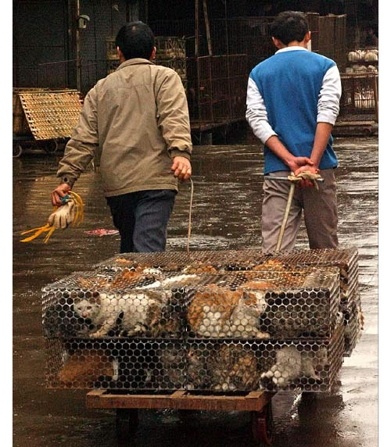
- Being run over by a car
- Extreme weather
- Injuries from fighting with other cats over territory
- Infections
- Lack of medical care
- Suffering around international events when cities are required to be cleaned up. (Photo left was taken during the Olympics 2008) 图解：在奥运前的城市整顿中，成千只流浪猫被捕捉和杀害，为了获取它们的皮毛和肉。照片摄于2008年3月。

Why are There so Many Stray Cats in Beijing?

为什么北京有这么多流浪猫？

- 因为猫没有做节育手术，所以数量成倍增长
- 一次生育大约出生六只小猫
- 对有些主人来说，给猫做节育手术的费用太昂贵
- 没有足够的宣传教育，告诉人们如何照顾猫和流浪猫
- 北京没有足够的机构帮助猫
- 许多人是因为养猫太贵而抛弃了自己的猫
- 也很少有项目阐述流浪猫的问题

- Because cats are not being neutered, the population expands exponentially.
- There are about six kittens in one litter.
- Getting cats neutered or spayed might be too expensive for some cat owners.
- Not enough education about taking care of cats or stray cats.
- There are not enough organizations to help cats in Beijing.
- Too many people abandon their cats, because they get tired of the responsibility or find it too expensive to care for them.
- There are few programs that address the problems of stray cats.
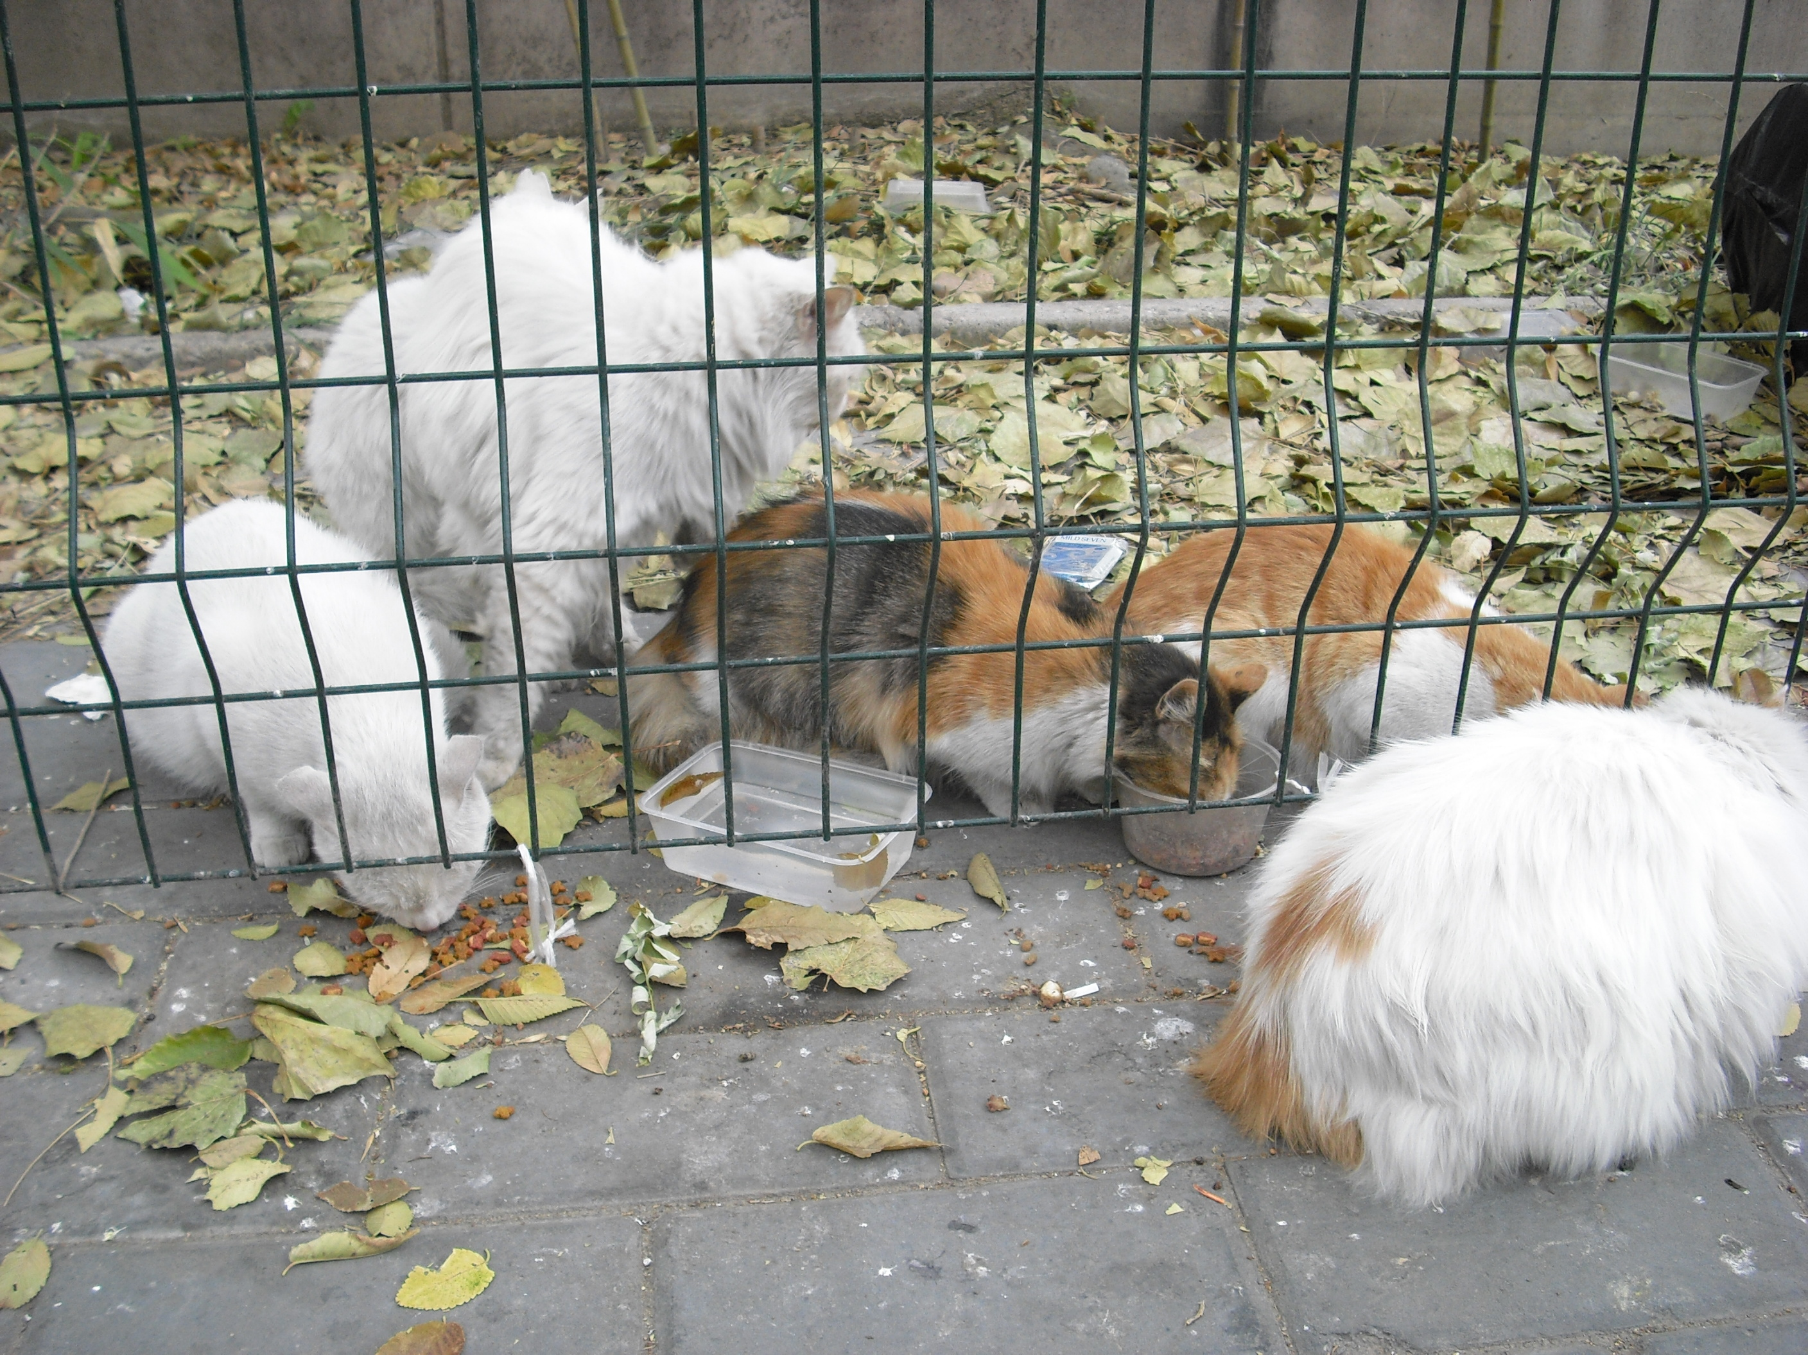

Stray cats devouring food left out for them by concerned cat lovers.
图解： 流浪猫在享用爱猫者留下的食物

What is the Best Way to Help Cats?

帮助猫的最好途径是什么？

- 给流浪猫对一些理解
- 研究TNR计划（诱捕、绝育和释放）
- 成为毛群的监护者（喂养它们并且监视它们的健康）
- 把流浪猫带到兽医那里做绝育手术
- 为它们购买防止致命疾病的疫苗（比如，狂犬病）
- 在兽医诊所或者动物保护组织做志愿者
- 参考本册子所提供的特定方法
- Be more understanding of stray cats.
- Research about the TNR (Trap Neuter and Return) technique.
- Become the caretaker (someone who feeds the cats and monitors their health) of a colony of cats.
- Bring stray cats to the vet for neutering and spaying.
- Pay for vaccinations against deadly diseases. (e.g. Rabies)
- Volunteer at a local veterinarian clinic or animal shelter.
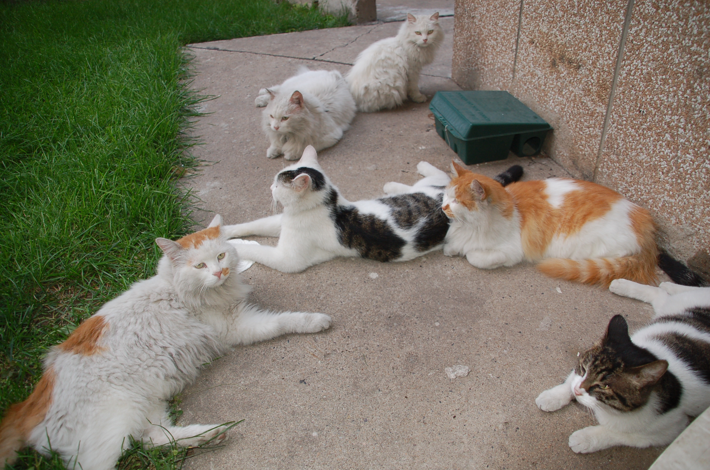
- See more specific ways you can help later in this booklet.
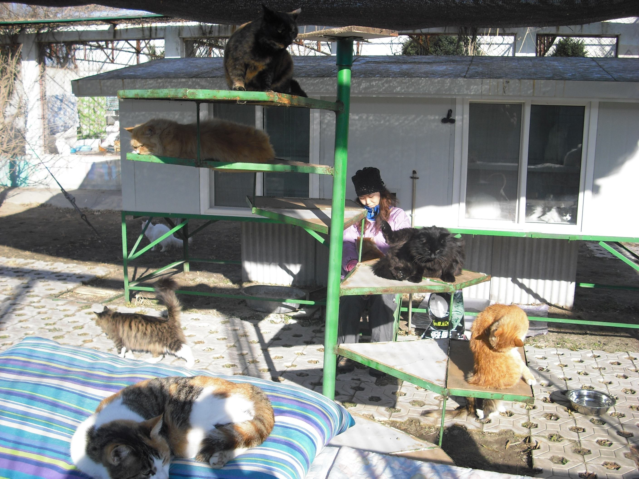
Neutered and spayed stray cats that return to their feeding place or to the caretaker who watches out for them.
Rescued sibling kittens at the ICVS veterinary hospital looking content to be where they are.

Rescued cats at the animal shelter enjoying the sun and looking forward to a comfortable life at a shelter that will care for them and not put them to sleep.

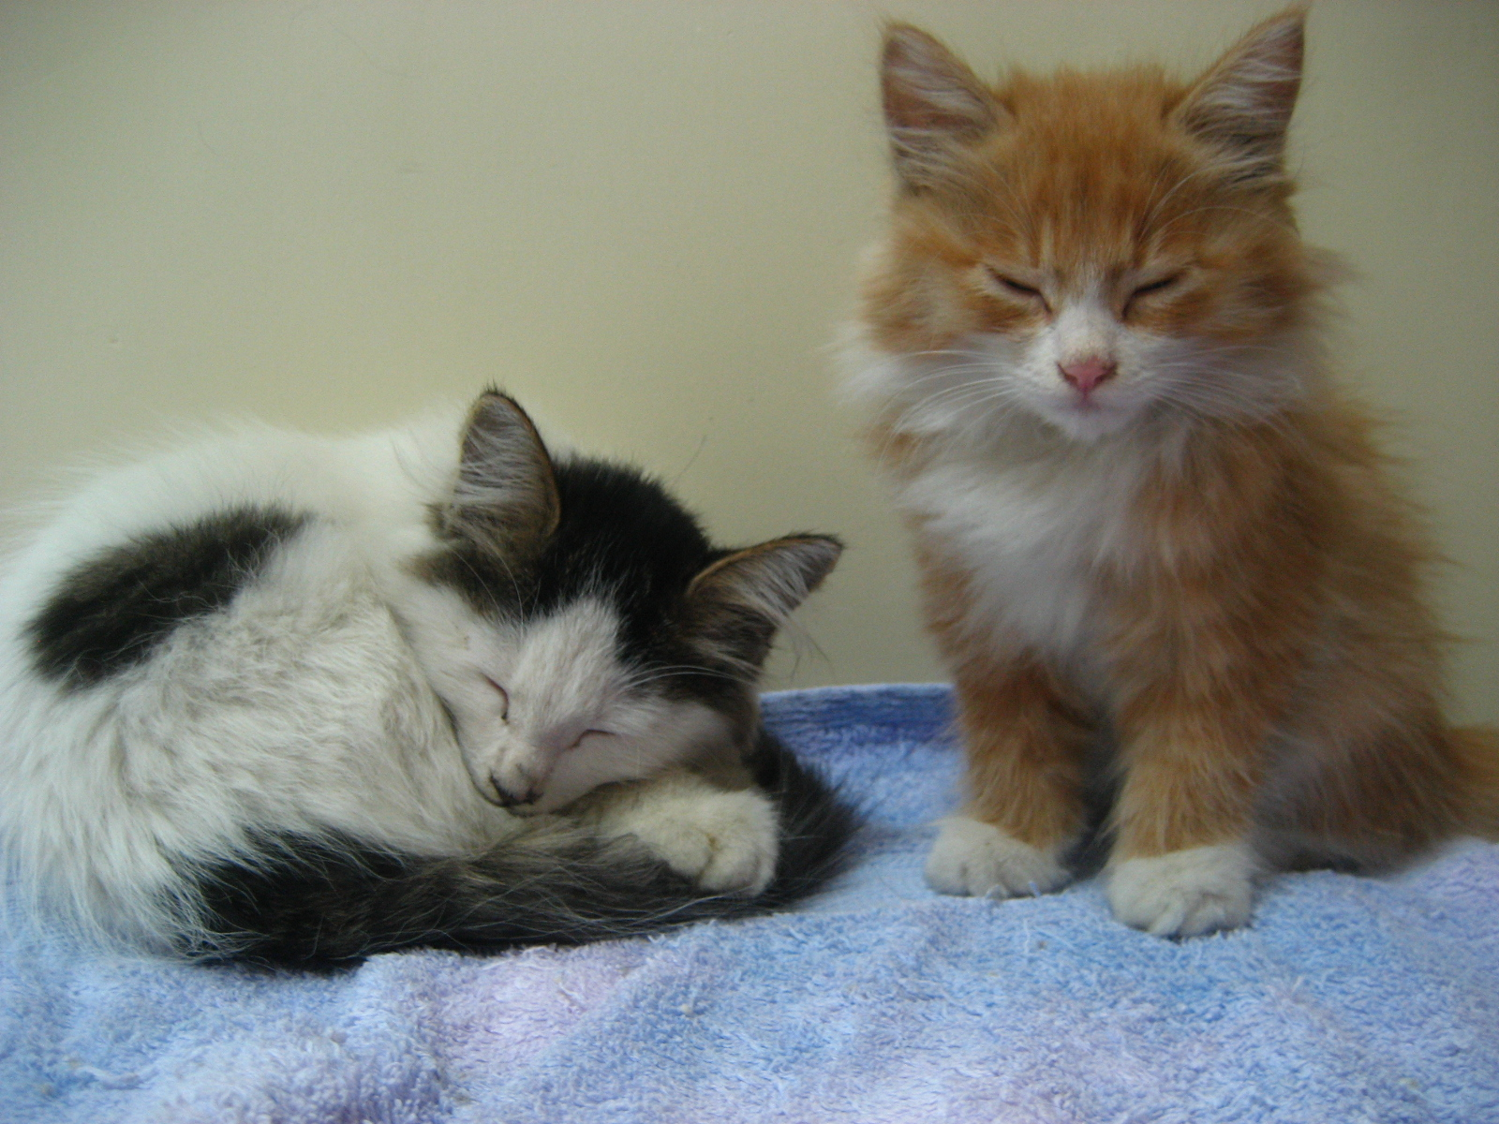

How to Spay and Neuter? 如何给猫做绝育手术？

- 在绝育手术之前，先要给猫做麻醉
- Before the operations the cats will be anesthetized.
Spay (Ovariohysterectomy) 卵巢摘除（母猫） 取出卵巢，输卵管和子宫, 皮下缝针。有时缝针线是不能自行消解的，那样的话，要么复诊去除，要么让猫留在诊所直到它们能够活动.必须让猫在诊所过夜. 摘除卵巢的母猫不会再生育，这就控制了流浪猫的数量。
- Removal of ovaries, fallopian tubes and the uterus.
- Stitches are buried under the skin. Sometimes stitches are not dissolvable and either a check up visit is required to remove them, or the cat should stay at the vet’s until they can be removed.
- The cat should remain in the Hospital overnight.
- A spayed female will no longer reproduce, helping to control overpopulation of stray cats.
Neuter (Castration) 去势（公猫）

动手术摘除睾丸,去势后的公猫不再生育，也不会太倾向于为抢夺领地和母猫而打架
- The testicles are surgically removed.
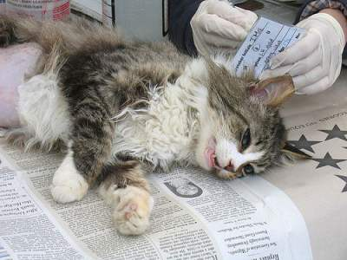
- Neutered cats will no longer reproduce and are less prone to get into fights over territory and females.
Female cat after undergoing surgery to spay her and ear-tipping.

图解：做过绝育手术和裁过耳尖的母猫

TRAP NEUTER AND RETURN

诱捕、绝育和释放

- 意味着用一种人道的方式诱捕流浪猫，并将其带到兽医诊所
- 兽医将会给猫做绝育手术，并且裁掉耳尖作为记号
- 给猫注射防止猫鼻气管炎、萼状病毒、猫肠炎和狂犬病的疫苗
- 从手术中恢复以后，猫被送回至监护者的收养所
- TNR被证明是非常成功的，而“诱捕和杀害的方法”已被历史淘汰
- 在许多人共同参与时，TNR的效果最好，所以请你的朋友帮助你
- 你们可以在群体中平摊费用
- 给做过绝育手术的猫做记号是非常重要的（裁掉耳尖或者做纹身，尽管纹身不大容易看见）
- It is important to trap the cat in a humane cat trap.
- The vet will neuter or spay and than ear-tip the cat.
- The cat will be vaccinated against FVRCP and Rabies.
- After the cat has recovered from the surgery it will be returned to the caretaker’s feeding place.
- TNR has proven to be very successful, while the “Trap and Kill method” has historically failed.
- TNR works best when many people work together, so ask your friends to help you.
- As a group, you can share the expense.
- It is important to mark the neutered or spayed cats in some way by ear-tipping or tattooing, though tattooing isn’t as visible
Advantages: No more new kittens, reduced noise, improved cat-cat-frelationships, lowered cat intake for euthanasia

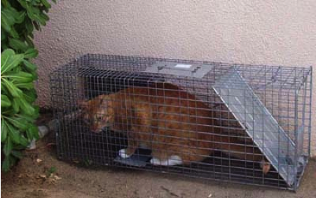
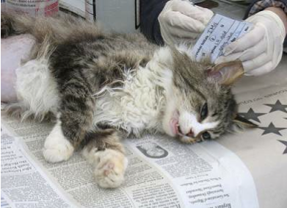
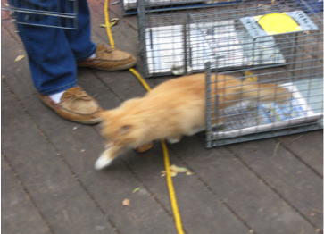
1. Stray cat caught in a spacious and humane cat trap. (TRAP)

2. Surgery to neuter or spay, cleaning, vaccinating, deworming and ear tipping. (NEUTER)

流浪猫被装进一只狂潮而且人道的猫 TRAP
绝育手术, 清洁注射疫苗，消毒和耳尖 NEUTER

3. RETURN cat to its previous habitat.
在原来的栖息地将其释放 RETURN

Humane Ways to Trap Cats

以人道的方式诱捕流浪猫

在诱捕之前：

1． 准备好笼子，让猫习惯于看到它
2． 通过给猫在笼中喂食，训练它们克服对笼子的恐惧。在训练阶段，将笼
子门打开，拿绳子扎好
3． 在诱捕日前的一到两天，给猫节食。它越是饥饿，就越容易进入笼子。

Before you trap:
- Prepare the trap and get the cat used to seeing it
- Train the cat to overcome fear of the trap by feeding it inside the trap. Keep the trap open with twist-ties or string-ties during the training period
- Withhold food from the cat for at least 1-2 days before the day of the trapping. The hungrier it is, the more likely it will enter the trap
在诱捕的当天：

1. 在猫的正常进食时间支起笼子
2. 把食物放进笼子，让猫自己走进去
3. 不要强行把猫赶进去
4. 确保你能将猫从笼子里拿出来之后，再让它进去
5. 不要让猫在笼子里待太久，用毛巾或者毛毯遮住笼子，以免它紧张
6. 把猫带到兽医处或者动物庇护所
7. 除非这只猫百分百地与你熟识，否则绝不要亲自去抓它然后塞进笼子。这样做可能会让它不快、紧张，而后可能导致你被抓伤。

On the day of the trapping:
1. Set the trap at the cat’s normal feeding time
2. Put food in the trap, and let the cat walk in by itself
3. Don’t force the cat into the trap
4. Only set the trap when you are able the get the cat after its trapped
5. Don’t leave it in the trap too long and cover the trap with a towel or blanket to keep the cat calm
6. Take the cat to the vet or to the shelter
7. Unless the cat is one hundred percent familiar with you, don’t grab it yourself and put in the cage. This could upset the cat and make it very nervous and could result in injuries to the humans
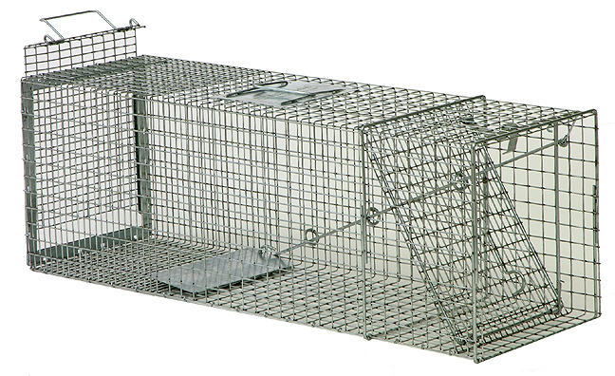
A humane cat trap.
图解：一只人道的猫笼

How Can I Help?

我该怎么做？

我们知道猫需要帮助。这里有一切简单的途径：

1. 最简单的
- 向下一页面上罗列的人们捐钱
- 给你的猫最绝育手术，请你的朋友们也这么对待他们的猫
- 与流浪猫交朋友，这样你就能比较容易地将它诱捕
- 支持保护中国流浪猫的立法

2．很简单的
- 人道地诱捕
- 给猫做绝育手术
- 成为猫的养护人
- 监察猫的健康，每年带它去看一次兽医

3 . 简单的
- 给流浪猫提供食物和水
- 人道地诱捕并为猫找到一个可靠的家。请新的主人给猫做绝育手术
- 把猫带到动物庇护所。提供给它做绝育手术的资金。
- 把猫当作你的宠物，给它做绝育手术，好好照顾它一辈子。
We know that the cats need help. Here are some easy ways:
- Donating money to the people on the following page.
- Have your own cat neutered or spayed and if friends of yours have cats ask them to do the same thing.
- Support legislation that will protect stray animals in China.
- Get Personally Involved
- Feed stray cats.
- Become the caretaker of the cat.
- Monitor the health of the cat, take the cat to the vet once a year.
- Find a reliable home for a cat. Ask new owners to neuter the cat.
- Bring it to an animal shelter.
- Provide funds to neuter the cat.

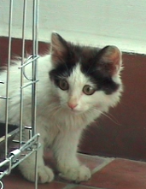
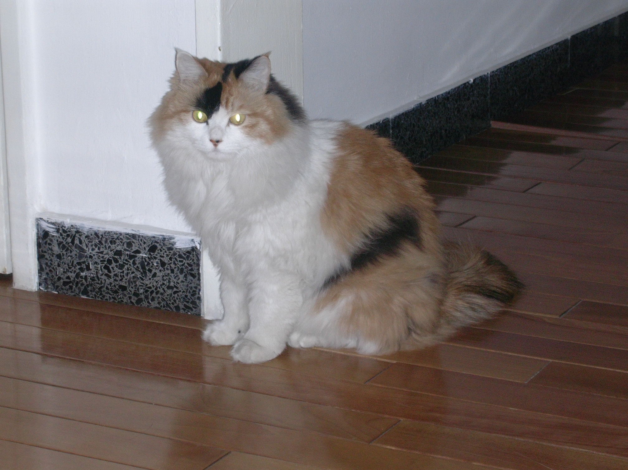

Two cats with a happy ending. Both were strays that managed to find good homes. One was even adopted and taken to Germany with her new owner.
图解：两只有着快乐归宿的猫。它们都曾经流浪，但最后找到了一个好的家庭。其中一只甚至被收养人带到德国，幸福终老。

ADDRESSES FOR DONATIONS

International Center for Veterinary Services (ICVS) – English and Mandarin Services
Tel: (8610) 8456-1939/1940/1941
E-mail: ICVS_CHINA@yahoo.com
Web site: www.icvsasia.com
Hours: Monday – Friday, 8:00 AM to 8:00 PM, Sunday 10:00 AM to 7:00 PM

Beijing Cat
Tel :6679-6620
SMS: 1350-131-5988
E-mail: scarlett@beijingcat.org

Yiya Petstore and Hospital
34 Gongtibeilu, Dongcheng District
65526178/ 65526177

Aikang Veterinary Hospital (Speaks English)
Chaoyang Park
45 Tianshuiyuan Dongli, Chaoyang District
Daily 9am-10pm
6501 8605

Beijing Ornamental Animal Hospital,
2/F, 7 Beisanhuan Zhonglu, Xicheng District
6204-9631, 6237-1359
Is run by the health and Quarantine Station of China...where you have to go for export health exam if you want to export your pet)

K.K Animal Hospital
801-802 Pinnacle Plaza, Shunyi District
Daily 9am-7pm
8046 2358, 133 1129 3008

BHAEEC Animal Shelter
Little West of the Aviation Museum in Xiaotangshan Town, Changping District.
Tel: (86-10)6179-1908.
Website: www.animalschina.org
Email: info@animalschina.org

Bibliography

(Feb. 29, 2008). The Humane Society of the United States. Retrieved September 27, 2008, from Why You Should Spay or Neuter Your Pet Web site: should_spay_or_neuter_your_pet.html

The Humane Society of the United States (2008). Helping Homeless Cats: Would you know what to do? [Brochure]. Washington, D.C.: The HSUS.

Zhang Luping. Beijing Human and Animal Environmental Education Center. [Brochure]. Beijing, China. Model Base for Companion Animals Protection in China and Organization of Association.

The Humane Society of the United States . Retrieved September 27, 2008, from Myths and Facts About Spaying and Neutering Web site: http://www.hsus.org/pets/pet_care/myths_and_facts_about_spaying_and_neutering.html

(16/9/2006 ). China Machete . Retrieved October 8, 2008, from The irresponsibility of cat feeders Web site: http://www.blognow.com.au/chinamachete/32627/The_irresponsibility_of_cat_feeders.html

Jiang, Steven ( August 4, 2008 ). CNN. Retrieved September 27, 2008, from An animal lover's Olympic nightmare Web site: http://edition.cnn.com/2008/WORLD/asiapcf/08/03/oly.beijjingcats/index.html

Kerasote, Ted (2008). Site pass. Retrieved September 27, 2008, from An Olympic disgrace Web site: http://www.salon.com/opinion/feature/2008/03/24/animal_cruelty_china/

Macartney, Jane (February 25, 2008). Time Online . Retrieved September 27, 2008, from Cats are out as Beijing starts to preen itself Web site: http://www.timesonline.co.uk/tol/sport/more_sport/article3427996.ece?fb_page_id=8004838698&

(2008). marvistavet. Retrieved September 27, 2008, from The Feline Spay Web site: http://www.marvistavet.com/html/body_the_feline_spay.html

(2008). wikiAnswers. Retrieved September 27, 2008, from How early can you spay a kitten? Web site: http://wiki.answers.com/Q/How_early_can_you_spay_a_kitten

( 4/5/08). WHY NEUTERING IS A GOOD IDEA. Retrieved September 27, 2008, from Neutering a male cat Web site: http://www.marvistavet.com/html/body_neutering_the_male_cat.html

Humane Way Raccoon/Cat Trap (Front Release) CLEARANCE. Retrieved September 27, 2008, from Wild Control Supplies Web site: http://www.wildlifecontrolsupplies.com/Merchant2/merchant.mvc?Screen=PROD&Store_Code=NWS001&Product_Code=914038&Category_Code=HW

(2000). Humane Trapping Instructions. Retrieved September 27, 2008, from Humane Trapping Instructions Web site: http://www.feralcat.com/trapinst.html

Little, Karen Alley Cat Advocates . Retrieved September 27, 2008, from Alley Cat Advocates Web site: http://www.alleycatadvocates.org/

(Friday, March 14, 2008). Animal Awakening. Retrieved September 27, 2008, from Killing Cats In Beijing: The Lies, The Fear, The Olympics Web site: http://animalawakening.blogspot.com/2008/03/killing-cats-in-beijing-lies-fear.html

The Cat Group. Retrieved September 27, 2008, from Feline leukaemia virus (FeLV) Web site: http://www.fabcats.org/cat_group/policy_statements/felv.html

About.com. Retrieved September 27, 2008, from Cat Scratch disease Web site: http://adam.about.com/encyclopedia/001614sym.htm

Marshell , Morgan (2005). For The Love Of Cat . Retrieved September 27, 2008, from What is a Feral Cat? What defines a stray? Web site: http://www.for-the-love-of-cats.com/Feral_Cats.html

(1999-2008). How to Turn a Stray Cat Into a Pet. Retrieved September 27, 2008, from Petsplace Web site: http://www.petplace.com/cats/how-to-turn-a-stray-cat-into-a-pet/page1.aspx

Enterprises, Polson Steps to Keep My Cat Safe From Bird Flu. Retrieved September 27, 2008, from Steps to Keep My Cat Safe From Bird Flu Web site: http://www.virtualpet.com/birdflu/cats/bfcsafe.htm

Kidhealth. Retrieved September 27, 2008, from Cat Scratch disease Web site: http://kidshealth.org/parent/infections/bacterial_viral/cat_scratch.html

(March 2007). Animal People Online. Retrieved December 1, 2008, from Chinese activists rescue more than 400 cats from Tianjin butchers Web site: http://www.animalpeoplenews.org/07/3/chineseactivistscats3_07.html

Ikuma, Carly (June 6, 2007 ). Humane Society International. Retrieved December 1, 2008, from hinese Animal Advocates Stop Brutal Slaughter of Cats in Tianjin Web site: http://www.hsus.org/hsi/confronting_cruelty/animal_cruelty_around_the_world/chinese_activists_rescue_cats.html

IFAW. Retrieved December 1, 2008, from Beijing Human & Animal Environmental Education Center Web site: http://www.ifaw.org/ifaw_international/join_campaigns/help_dogs_and_cats/stronger_laws_to_save_dogs_and_cats/help_find_new_homes_for_china%27s_unwanted_dogs/beijing_human_amp%3B_animal_environmental_education_center.php

Luebkeman, Erin ( March 11, 2008 ). Humane Society International. Retrieved December 1, 2008, from Roundup of Beijing’s Cats Prompts Widespread Condemnation Web site: http://www.hsus.org/hsi/dogs_and_cats/street_animal_welfare/roundup_beijings_cats_31108.html

Peng, Mary (0ctober – December 2008). International Center for Veterinary Services.
Mary Peng made major contributions to both my research and the editing of my project.

Bruce, Michelle (November – December 2008). Beijing Human and Animal Environmental Education Center.
Michelle Bruce made a major contribution to both my research and the editing of my project.

Pictures
(© 2007-2008). Jamd. Retrieved October 8, 2008, from Animal Group To Sterilize Stray Cats In Beijing Web site: http://www.jamd.com/image/g/57311141

(2008). KChristieH Blog. Retrieved October 8, 2008, from China committing cat genocide Web site: http://www.kchristieh.com/blog/?cat=7

(February 24th, 2008). Kitty Mowmow’s Animal Expo. Retrieved October 8, 2008, from Cats are out as Beijing starts to preen itself Web site: http://www.kittymowmow.com/2008/02/24/cats-are-out-as-beijing-starts-to-preen-itself/

(July 15, 2008). daylife . Retrieved October 8, 2008, from Reuters pictures Web site: http://www.daylife.com/photo/01DrdmQh0M4Xe

(05/03/08). Chicago Area News Archives . Retrieved December 23, 2008, from October 16 is National Feral Cat Day Web site: http://www.triplerpets.org/news/chicago.htm

(2008). Missing Pet Partnership. Retrieved December 23, 2008, from Recovery Tips - Displaced Cat Behavior Web site: http://www.lostapet.org/recovery-displacedcat.php

Charlotte Landwehr
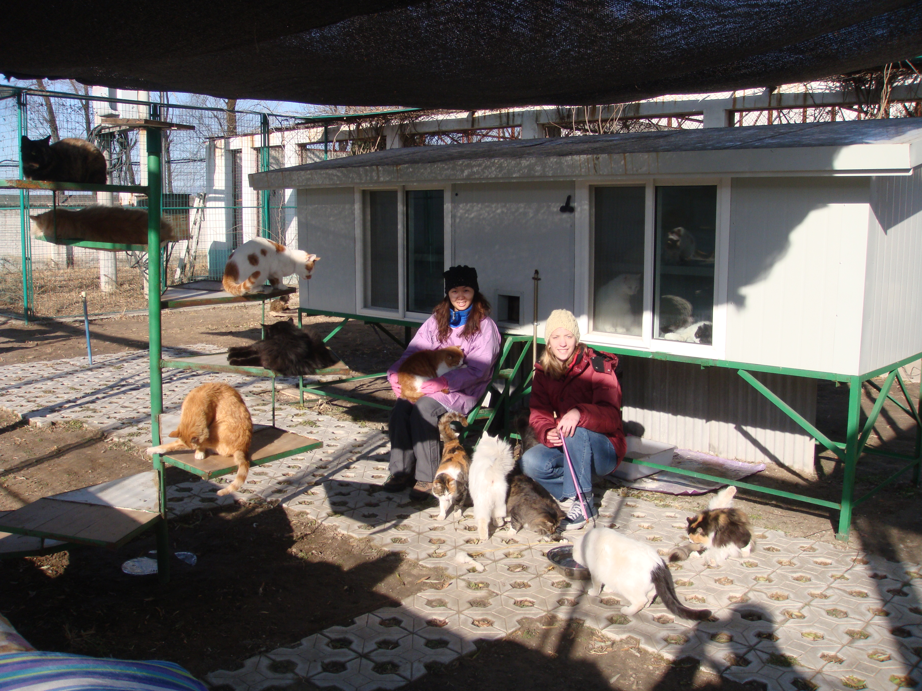
12/ 01/ 2009

